Summary of Project

PI: Annette Hilton
Collaborative faculty: Kelly Caylor, Arturo Keller, Naomi Tague (Bren School Environmental Science & Management)
Scope: PhD Dissertation Chapter

Brief description: Digitization of historical U.S. Geological Survey water data using machine learning approaches.

Abstract
Between 1879-1980, hundreds of reports containing measurements of precipitation, stream discharge and groundwater well levels were published by the U.S. Geological Survey prior to digital record keeping. Today, many of these historical documents are stored online in the USGS Publications Warehouse, but their content is largely unknown and unutilized. These historical measurements can impact water research and our understanding of environmental changes in the U.S., but the ability to utilize these records is constrained until each measurement is digitized. Here we employ machine learning to facilitate the retrieval, selection, digitization, and indexing of thousands of historical water records from the USGS archives. Using the state of California as an example, we digitize 70,000 tables of data related to groundwater, springs, streamflow, precipitation, and water supply. We demonstrate the utility of these newly digitized data in a case study that examines xxx river and its changes throughout time with California water projects. Our machine learning workflow is open source, and all transcribed data are made publicly available for future use. Our work demonstrates the efficacy of machine learning to restore archival data with notable research and public value.

Quantity of data
- 50,000-70,000 unique tables of water data from California, years ~ 1879-1980
  - Each table will have final products (.json, .csv, HTML, metadata)
- Our team will likely curate our own aggregation of some of these tables based on water data type (groundwater, springs, etc.) but will not curate all of the tables
- For purposes of publishing on HydroShare (or elsewhere), it may be necessary to group all of the tables together or in categories (still working this out)
- This work is intended to be published in a peer reviewed paper that will also link to where the data are housed and our scripts and code for reproducibility
- If time, we aim to make a user interface (example: R Shiny App) where users may explore data available

Final products
- PDF page/ .png file
- .json file
- .csv file
- HTML file
- Metadata file

Data storage/publishing
Data very likely will be published on HydroShare (https://www.hydroshare.org/) . HydroShare has minimal metadata requirements. I have (PI) published data on HydroShare previously. Personal contact at HydroShare/CUAHSI relayed this information:

"Metadata and indexing. HydroShare has very minimum requirements for metadata and loose recommendations for what to include, you can read about them here. There will be a key words field and this will be useful for making your resource as discoverable as possible. From my perspective, you will probably want to include a README with some of the information that doesn't fit into the fields that we have on the site. A couple of things that I like to include are
  - a table with variables and their units defined (though I think you have just groundwater levels, so that's not as necessary)
  - a small paragraph on methodology that points to your paper,
  - (sometimes) an example R or python script for how to load and make a small figure or summary table is a nice addition to show people how to get started with it.
- HydroShare space limitations. We allow 20 GB per account; however, we do sometimes allow people to make special requests and bump up that limit. If you're over 20 GB, consider reaching out and seeing what we can do! More details are on this HydroShare page: https://help.hydroshare.org/about-hydroshare/policies/quota/."

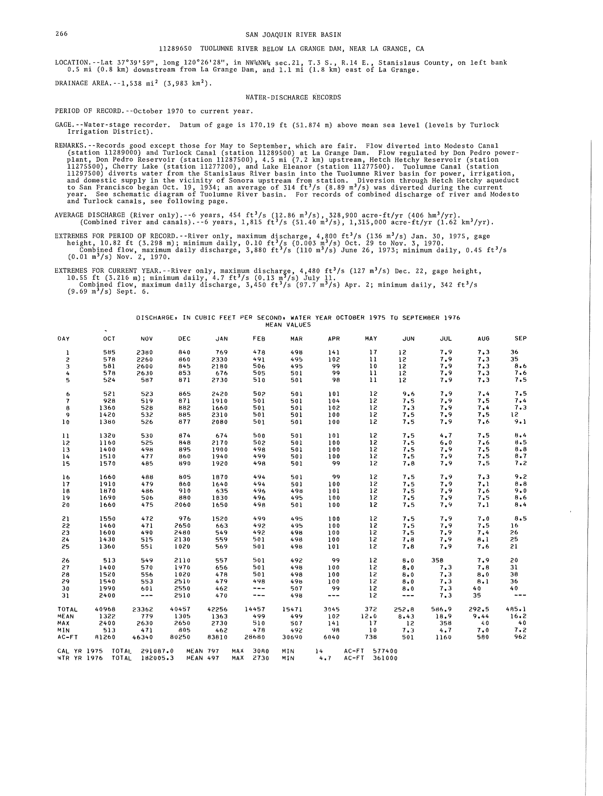
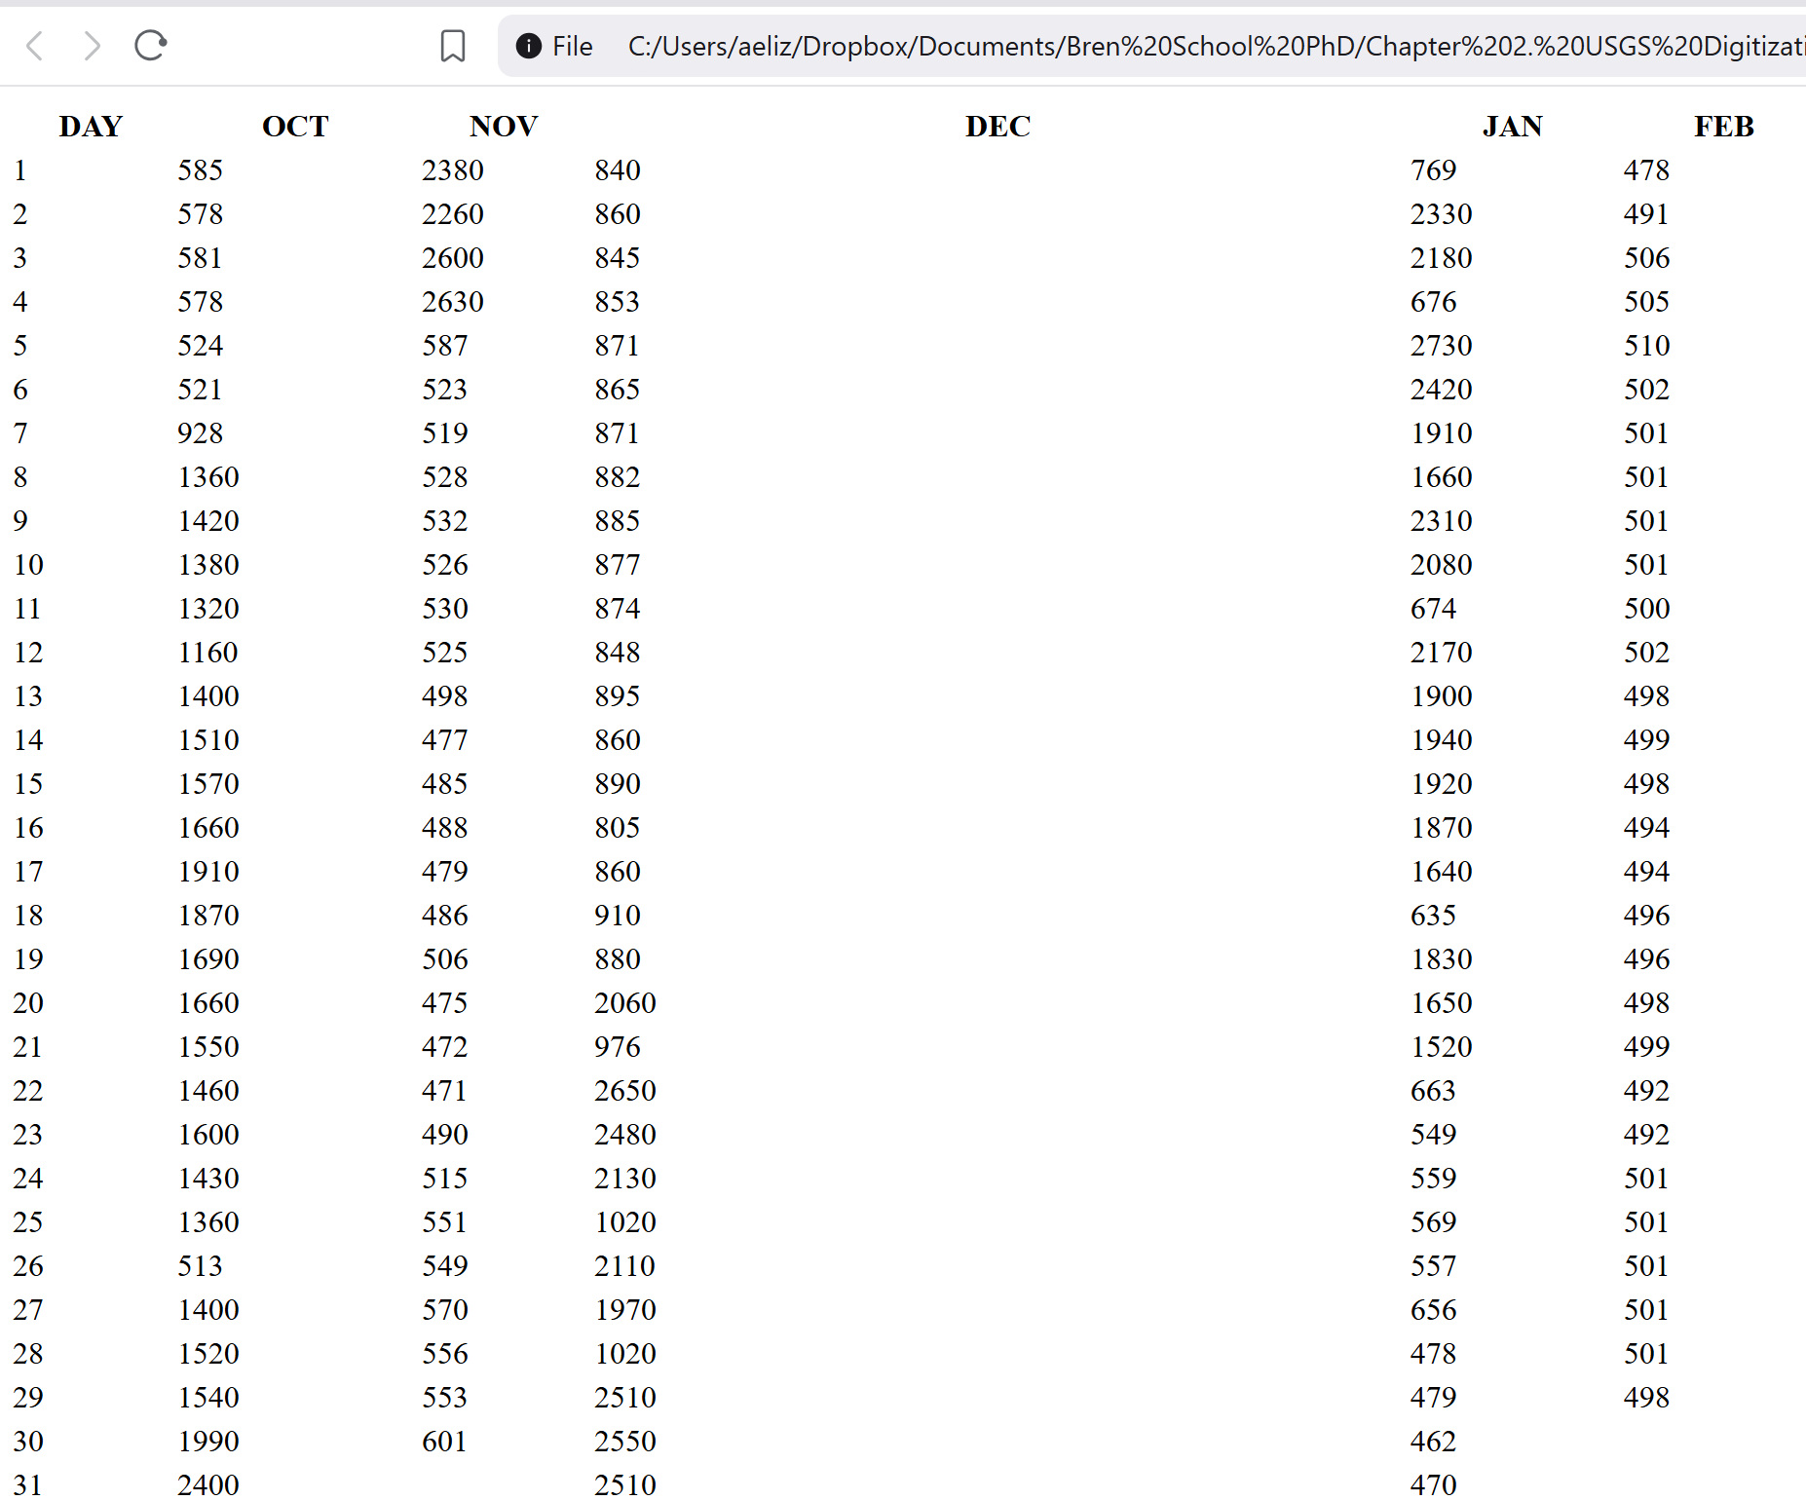
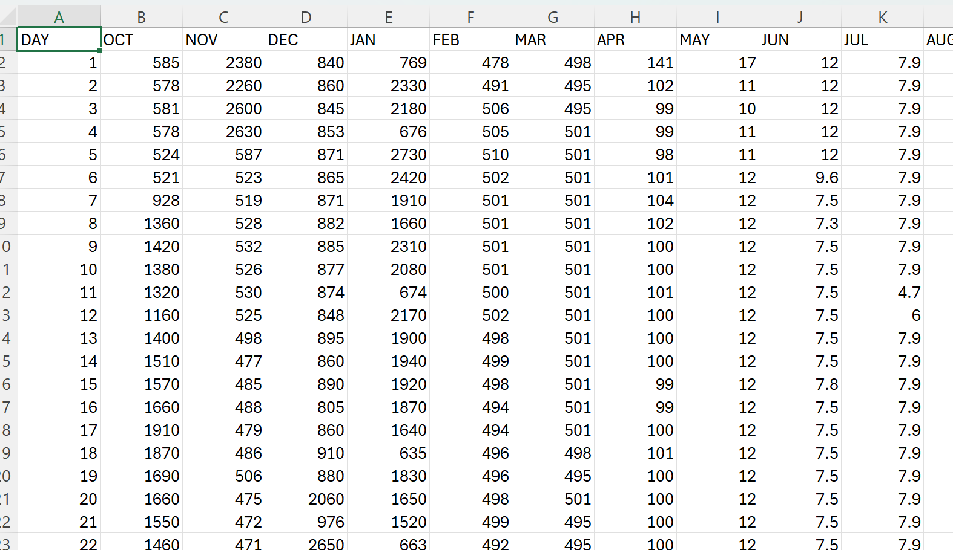
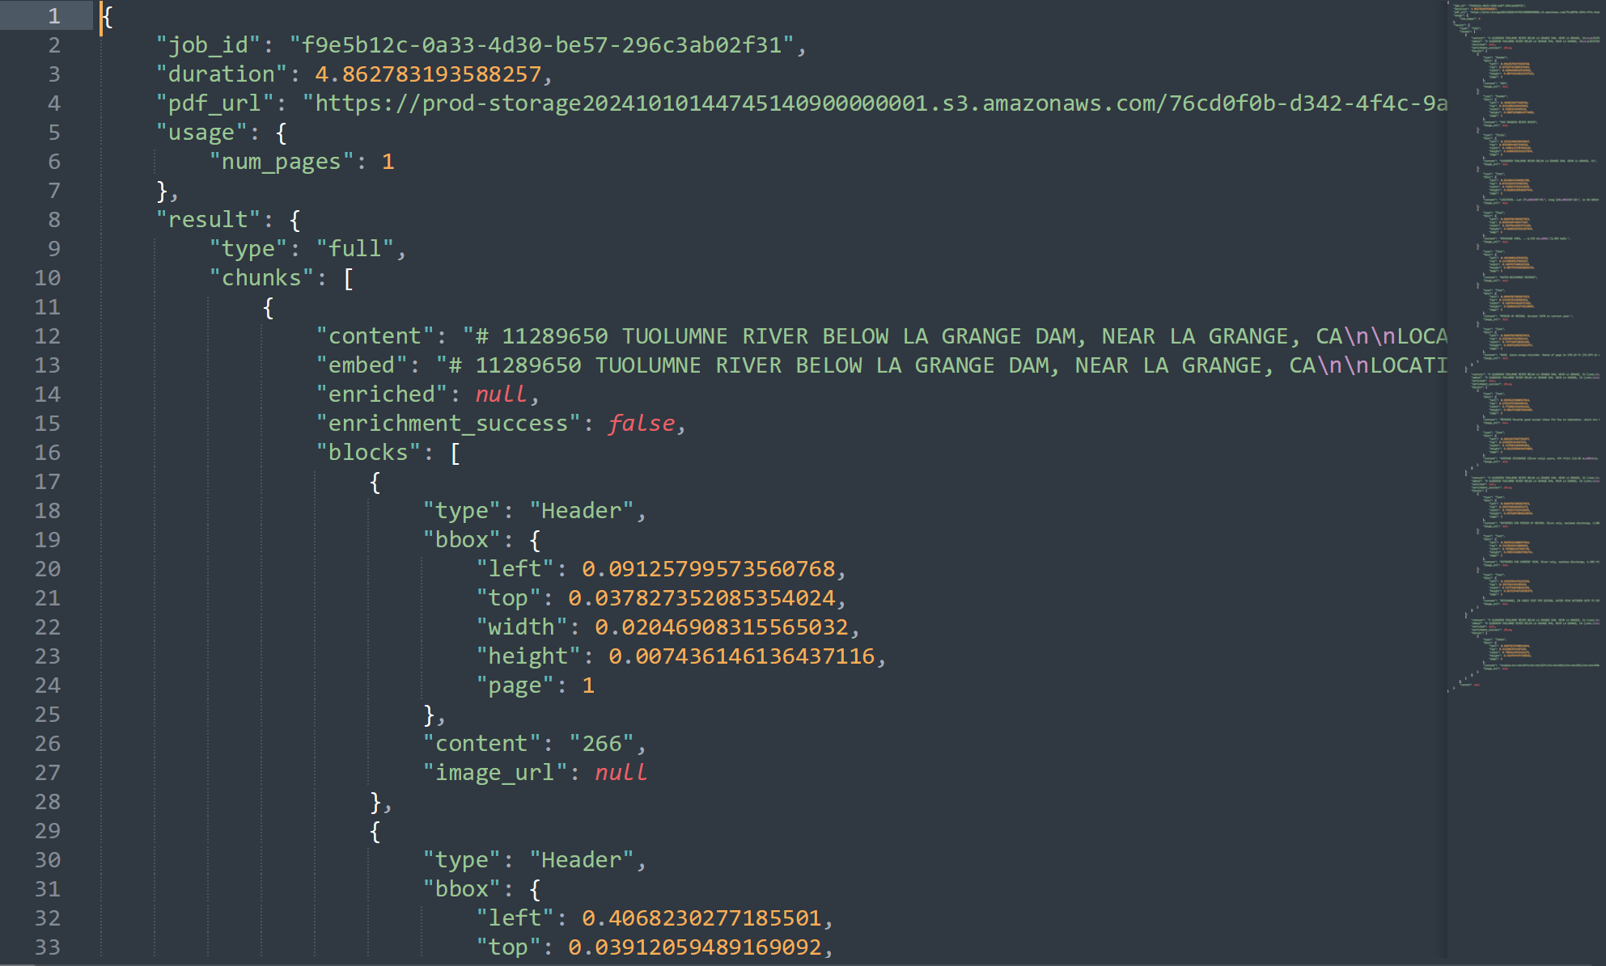
Example Workflow (Original PDF as image file → .json → .csv, HTML)
Metadata extraction via LLMs

Metadata are being extracted on ~70,000 tables of data via Large Language Models (LLMs).
We are going through several rounds of hyper parameterization to facilitate the accurate extraction of information. We also have a subset of the data tables that were classified by hand by team members–we will also do a comparative to see how well the LLMs perform vs. human classification.

We are trying to balance what the LLMs are capable of extracting while pulling as much information as possible to make the data searchable and as useful to researchers as possible.

Categories of metadata:

- Water category
  - Example: groundwater, stream discharge, precipitation, springs, chemical analyses
- Water sources
  - Example: name of actual river, local area
- Location name
  - City, County, State
- Latitude/Longitude
  - If applicable
- Township, Range, Section
  - If applicable
- Date
  - If specific date is available
- Time range (year span)
  - Example: 1950-1975
- Daily or monthly data
  - If document lists daily or monthly measurements
- Units of measurement
- Notes/Description
  - Anything that is in the table header/page title (for additional information and context)

- Original citation (document, page number) always linked to the metadata

